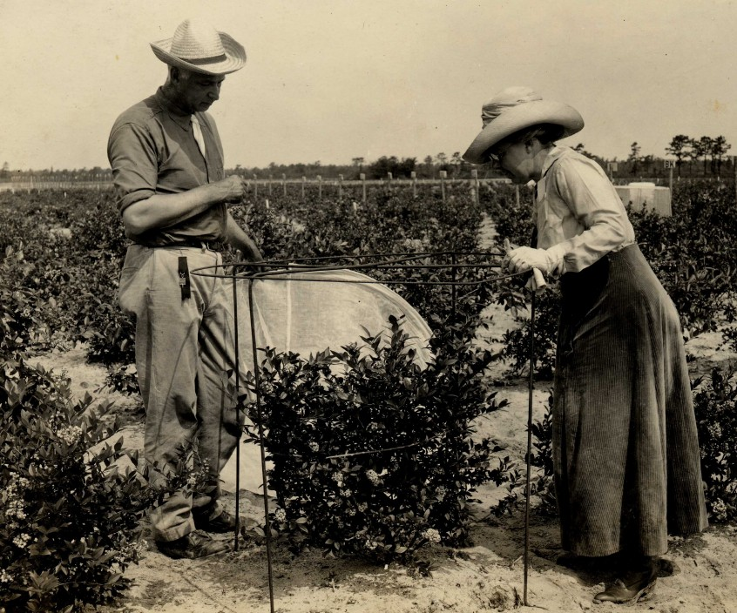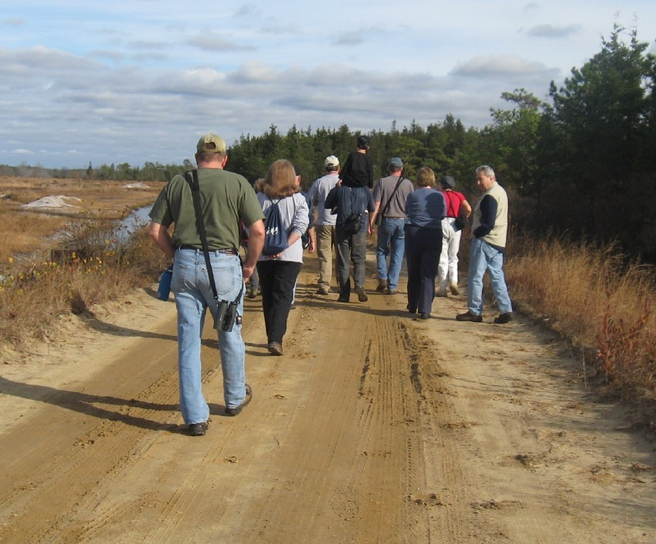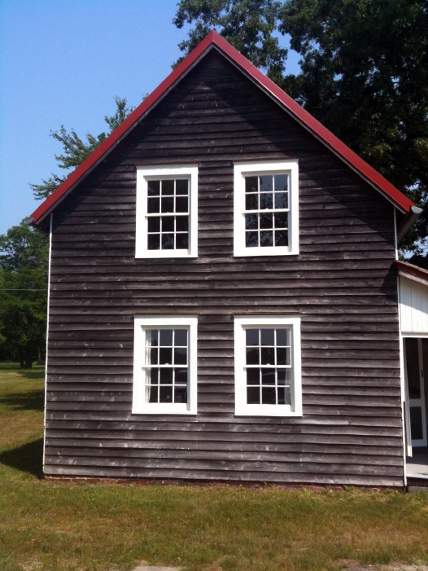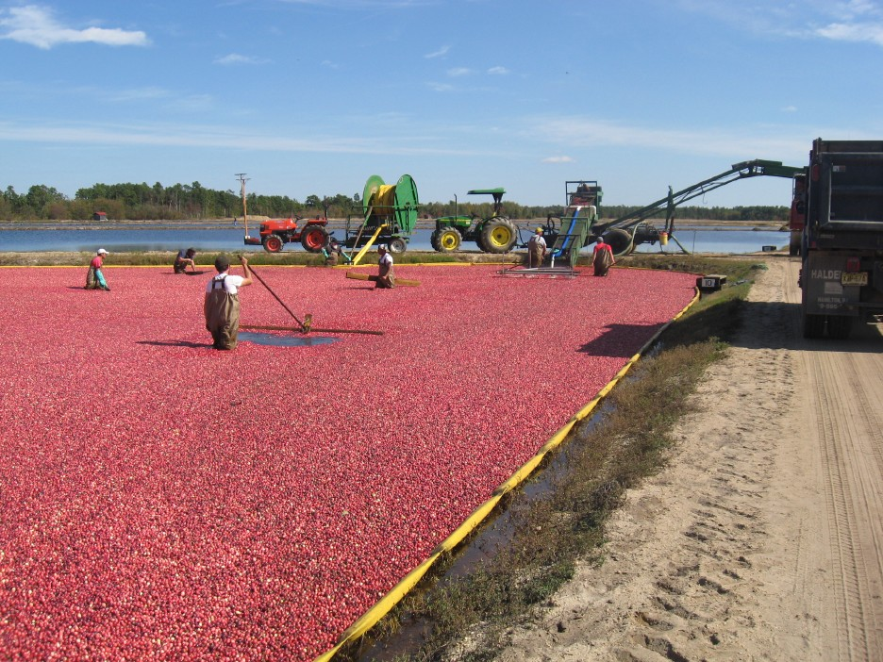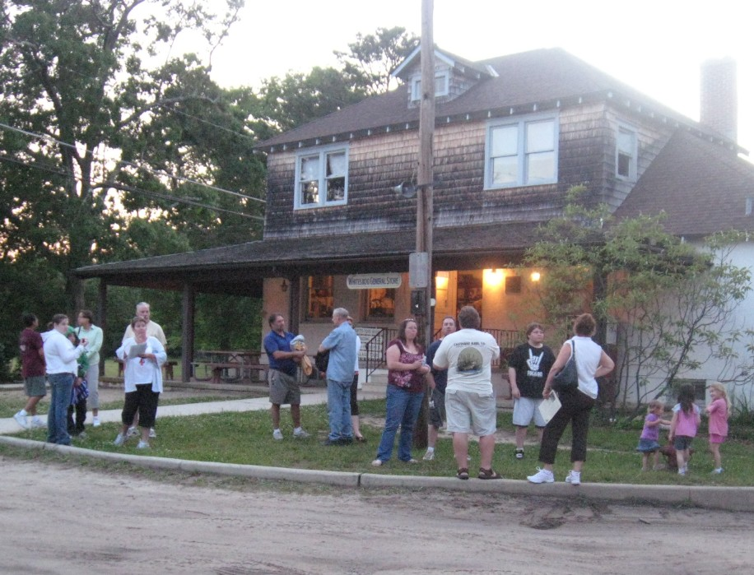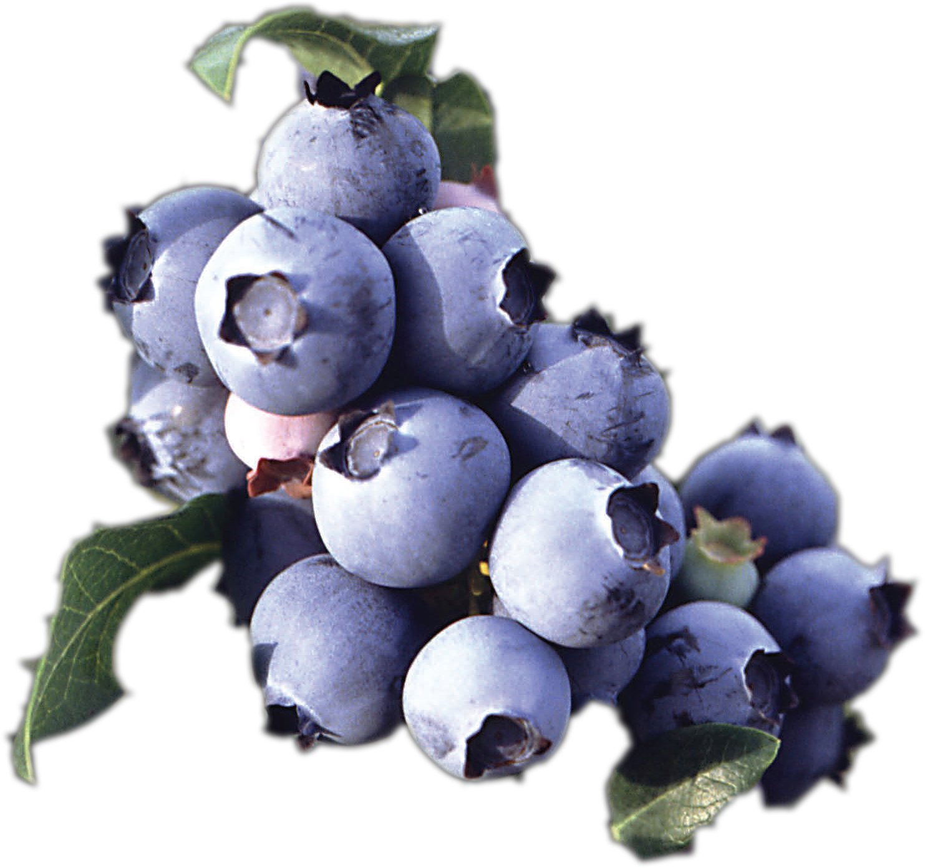

Whitesbog Audience Research Study
September 15, 2011
Heritage Consulting Inc

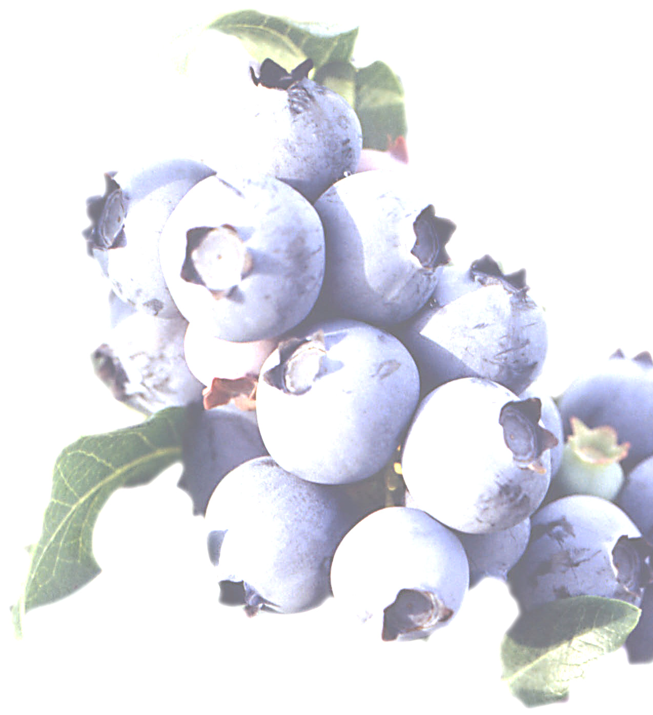

Table of Contents

Executive Summary 2

Introduction 3

Survey Design 6

Survey Results 7

Recommendations 21

Credits 23

Appendix 24

Executive Summary
The Whitesbog Preservation Trust is an active organization whose mission is “is to restore, protect and enhance the land, sites, and buildings at Whitesbog and to provide educational and interpretive programs and materials about the history, culture, and natural environment of Whitesbog.” Whitesbog has an active programming base, strong group of volunteers and supporters, and an outstanding historic resource. The Whitesbog Audience Research Study built on this strength and looked for deeper information about “Who visits Whitesbog? Why do they visit Whitesbog? and What do they take away?” More than 250 people responded to the survey, and while it is not possible to calculate the exact response rate for the survey, as it was forwarded to selected organizational partners and personal email lists, but in consideration of an email list of
1,000 addresses, approximately 25% of recipients responded to the survey.

Key findings of this study revealed important information about Whitesbog visitors:
• Visitors look to the internet first for information, but also rely heavily on word of mouth for information about the historic and natural sites they plan to visit. Whitesbog should use its website as a portal and public “face” of this rich historic site.
• Motivated to learn and enrich their understanding, visitors primarily visit historic and natural sites to pursue information. Educational programming and interpretation is crucial to meet this need.
• Historic preservation, cultural heritage, and blueberry culture are the top interests for visitors; Whitesbog should emphasize these thematic areas during the upcoming year.
• There are two visitor groups at Whitesbog, those that enjoy guided tours and structured programming, and those that like to discover at their own pace with self‐guided experiences. Whitesbog must accommodate both types of visitor groups to meet the needs of respondents and provide self‐guided brochures and resources for those that visit
outside of regular hours and structured programs.
• Visitors gave Whitesbog high marks for their visitor experience, and learned about the three core areas of Whitesbog’s mission statement.
• Visits to Whitesbog were very valuable for respondents, and many shared the personal impacts of their visit and ongoing relationship with Whitesbog. Many were motivated to get involved in activities and efforts in historic preservation, cultural heritage, and the environment as a result of their visit.
There are exciting prospects contained in this study, and Whitesbog has a valuable opportunity to incorporate these findings to better meet the needs of its current and future visitors.

Introduction
Heritage Consulting Inc. was approached by the Whitesbog Preservation Trust in 2010 to help the organization understand its visitors and inform the organization’s programming to better meet the needs of its audience. The Whitesbog Preservation Trust submitted a successful grant application to the New Jersey Cultural Trust in 2011 for an audience research study. This study looked at Whitesbog’s mission statement, activities, and visitor impacts to understand what visitors are looking for, what they take away, and what they do after they leave this Pinelands treasure.

Heritage Consulting Inc. developed an online survey that was sent to more than 1,000 current and potential visitors to understand their perceptions and expectations when they visit Whitesbog, This survey was open for seven weeks with two reminder emails sent to the entire 1,000 contact email list compiled by the Whitesbog Preservation Trust. At its close, 247 surveys were
completed, an estimated 25% response rate.1 Additionally a paper survey was also conducted June
25th, 2011 at the Whitesbog Blueberry Festival, and these completed surveys were entered into the online survey data base. Paper surveys were also available at the general store and several Whitesbog outreach events.

This report includes the results of the survey and recommendations for Whitesbog to use this information for future programming and continuing evaluation programs at this historic site.

Why Evaluate?
Evaluation incorporates the mission and activities of an organization with its impacts and outcomes. Evaluation allows historic sites to understand the effectiveness of their programs and the educational experiences they provide. Evaluation measures outcomes and impacts of specific programs on participants and visitors. A strong evaluation program measures these over time, and builds historical reference points and an organizational history, so the Board and staff can set goals, performance standards, and measure progress.

Evaluation Components
From the mission of Whitesbog Preservation Trust, there are two central elements that guide the organization, and are important to guide this study:

Preservation: Whitesbog has a primary mission to restore and protect the land, sites, and buildings at Whitesbog. This goal is primarily technical. Through condition assessments and architectural evaluation, surveyors can assess the quality of land, site, and building preservation
activities at Whitesbog.

1 The total sample population is unknown. The Whitesbog email list of 1,000 names is the initial population, but the survey was forwarded to other relevant distribution including the Pinelands Preservation Alliance Facebook page and organizational partner email lists in order to maximize the number of responses. For additional information see subheading “Possible Biases”

Interpretation: Whitesbog provides educational and interpretive programs and materials about the history, culture, and natural environment of Whitesbog. This goal can be measured by surveying those that have participated in interpretive activities at Whitesbog. Whitesbog offers a rich diversity of programs that include history, culture, and nature. This study asked participants and visitors directly about their experiences, preferences, and opinions to better assess current interpretative programs at Whitesbog.

Evaluation Criteria of the New Jersey Historical Commission
The New Jersey Historical Commission has outlined specific questions that interface directly with this study. These were strongly considered and incorporated into the study:

• Does Whitesbog understand the needs and characteristics of current and potential audiences, and do you use this information to inform your interpretation?
• Does Whitesbog vary program content techniques according to visitor age, interest, learning styles, and physical needs and abilities by using a variety of presentation techniques to meet audience needs interests and abilities and to achieve organizational and educational goals?

Audience Research & “Making Meaning”
Museums across the world are facing unprecedented challenges in light of declining visitation, financial stress, and aging volunteers. Some museums and historic sites find themselves struggling to be relevant to their visitors. As an attraction, museums find themselves competing with other leisure time activities including digital media, virtual environments, and an ever‐ expanding sea of information.

In the past sites and museums emphasized presenting their collections, and allowing visitors the privilege to visit. Now, that approach has been overturned as museums are taking active steps to invite visitors to their site and create programs that have meaning for them. Instead of being about something, sites and museums have moved to being for somebody.2 In order to understand how well museums are serving “somebody,” audience research evaluates the interest, understanding, and quality of visitor experiences to determine how well sites serve that “somebody.”

Historic and natural sites serve a variety of roles for the visiting public. They educate, inform, shape experiences, and provide inspiration and self‐reflection for those who visit. Through access to information, stories, buildings, objects, landscapes, plants, animals, and other features, visitors

2 Weil, S., "From Being about Something to Being for Somebody: The Ongoing Transformation of the
American Museum", Daedalus 128/3 (1999):.229‐258.

see themselves and their culture reflected in ways that encourage new connections, meaning‐
making and learning.3
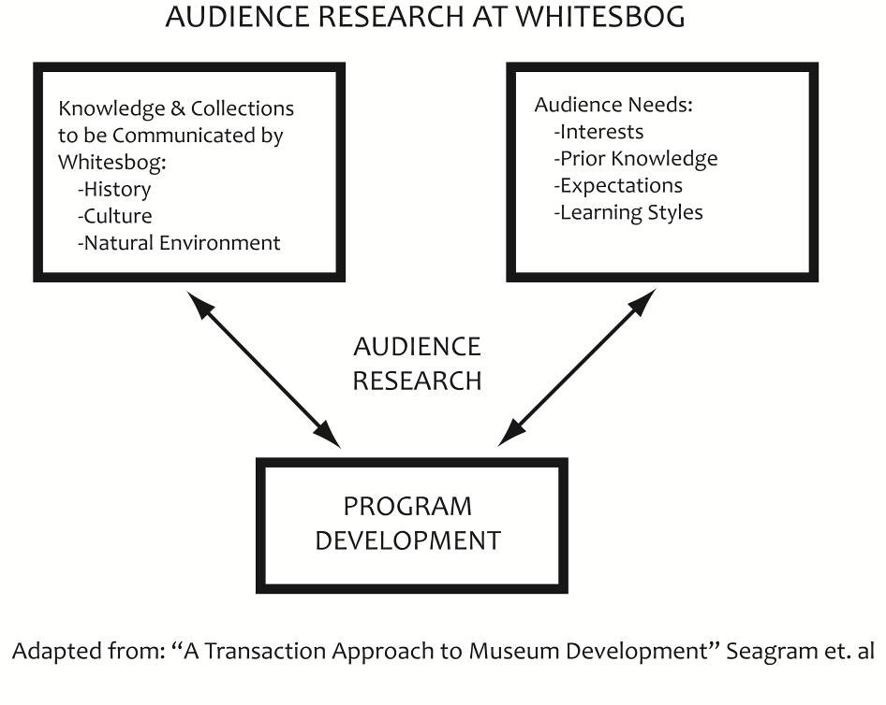
Figure 1: Audience research incorporates both the collections and knowledge of Whitesbog with audience needs and interests.

Logic Model & Impact Evaluation
This survey used a logic model to measure impacts and outcomes from visitor experiences at Whitesbog. A logic model illustrates the effects and results of an activity. In the case of Whitesbog, the logic model identified what visitors took away from their experiences at Whitesbog. The logic model incorporated Whitesbog’s mission, general programs and activities, and drafted what visitors took away in the short term (what visitors learned at Whitesbog) and what visitors took away in the medium term (what visitors did after they left Whitesbog). Working with Whitesbog staff, the logic model identified goals with respect to Whitesbog’s mission statement “to provide educational and interpretive programs and materials about the history, culture, and natural environment of Whitesbog.” This model incorporated scholarly background information from current audience research. On the next page is a sample logic
model (Figure 2).4

3 Silvennan, L., "Visitor Meaning Making in Museums for a New Age," Curator 38(3) (1995): 161 ‐169. Weil, S., "The Museum and The Public”, Curator 16(3) (1997): 257‐271.
4 “Logic Model” by Shaping Outcomes from http://www.shapingoutcomes.org/course/model/index.htm

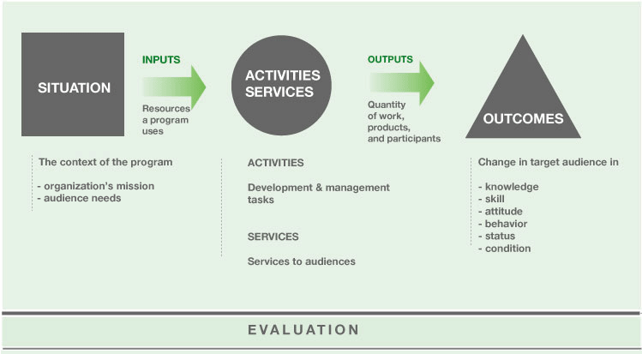Figure 2: The audience survey for Whitesbog incorporated elements from a logic model to better understand the impact of activities at the historic site

Survey Design
In preparation of the survey, Heritage Consulting reviewed existing brochures, evaluation materials, and information about Whitesbog Village. Additionally, Heritage Consulting performed a thorough review of survey literature to ensure that the methodology was current.

On April 7, 2011 Heritage Consulting attended a kickoff meeting with Whitesbog Executive Director Susan Phillips to identify key goals and questions for the audience research project. These central questions included “Who is visiting Whitesbog?” “Why are they visiting Whitesbog?” and “What interests them?” The draft survey went through a number of iterations.

A careful review of current literature in museum and historic site evaluation identified leading theories in experience and learning strategies as well as current efforts in evaluation. In the draft process, questions were edited and reworded to be mindful of both survey length and
effectiveness of key questions identified in the first meeting. Draft surveys were also distributed to Whitesbog Public Programs Committee members, board members, and several trustees. A follow‐ up meeting was held on May 9, 2011 where Phillips reviewed an initial draft survey that had translated broad questions into a specific survey questions. Some of these key questions fell into specific survey areas including: visitor demographics, leisure habits, learning strategies,
experience evaluation, and impact evaluation. After the survey was reviewed and approved by
Whitesbog, it was uploaded online and went “live” on June 19, 2011 for a seven week period.

Survey Dissemination
This survey used a multi‐method approach to reach the largest audience possible relative to the constraints of this project. The primary means to reach the audience was through an email invitation to 1,000 people from Whitesbog’s master email list. Whitesbog’s email list had thousands of names, but over time, some of these email addresses had gone dormant or were deleted. Whitesbog emailed an invitation to take the online survey to the edited email list of 1,000 names. Whitesbog also emailed follow‐up invitations twice to encourage greater participation.

Additionally, a paper survey was prepared for the annual Whitesbog Blueberry Festival held on
site on June 25, 2011 and placed at the membership table. Flyers were also handed out to attendees to encourage them to complete the survey online. Thirty‐two paper surveys were completed at
the Blueberry Festival and these were entered into the online survey. Paper surveys were also available in the general store for seven weeks, and at several Whitesbog outreach events.

Whitesbog also forwarded the survey link to additional organizational partners to broaden the participation pool. These included the Pinelands Preservation Alliance Facebook page, where a link was placed, advertising the survey.5 The survey invitation was also forwarded to the email lists of several organizational partners.

Possible Biases
The survey dissemination included some inherent biases, even though the survey team worked to minimize these. The use of an electronic survey meant that those without an email address provided to Whitesbog were unable to take the survey. Paper surveys were provided at the Blueberry Festival, general store, and outreach events in an effort to minimize this bias. The online survey methodology resulted in an under sampling of those who had not visited Whitesbog. Dissemination of the survey on the Pinelands Preservation Alliance (PPA) Facebook page and other electronic venues attempted to minimize this bias. The dissemination of both surveys and survey flyers at the Blueberry Festival gave great exposure at Whitesbog’s most popular event in an effort to get the most responses possible.

Survey Results
The first response received for the Whitesbog survey was received on June 20, 2011, and the final response received was on August 9, 2011. This survey was open for nearly seven weeks. 267 respondents began the survey, and of those, 245 fully completed the survey, a 91.8% completion rate. It is not possible to calculate the exact response rate for the survey, as it was forwarded to a listserv and placed on a Facebook page, but in consideration of an email list of 1,000 addresses,
approximately 25% of recipients responded to the survey.

5 The PPA has 1,651 “friends” on its Facebook page. It is unknown how many respondents from this page completed a survey.

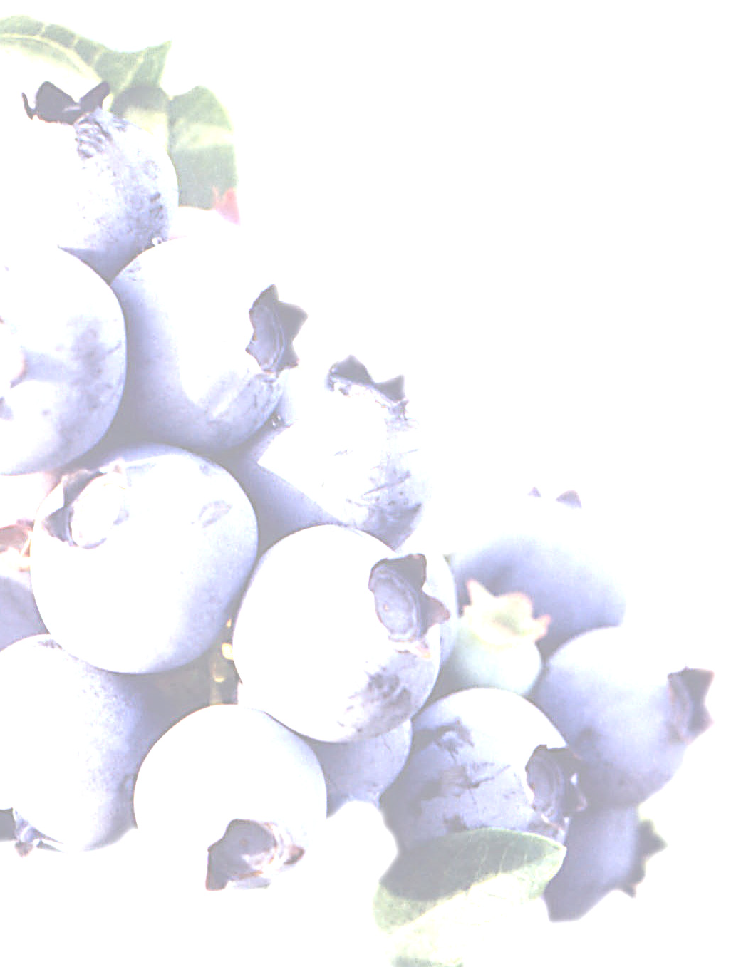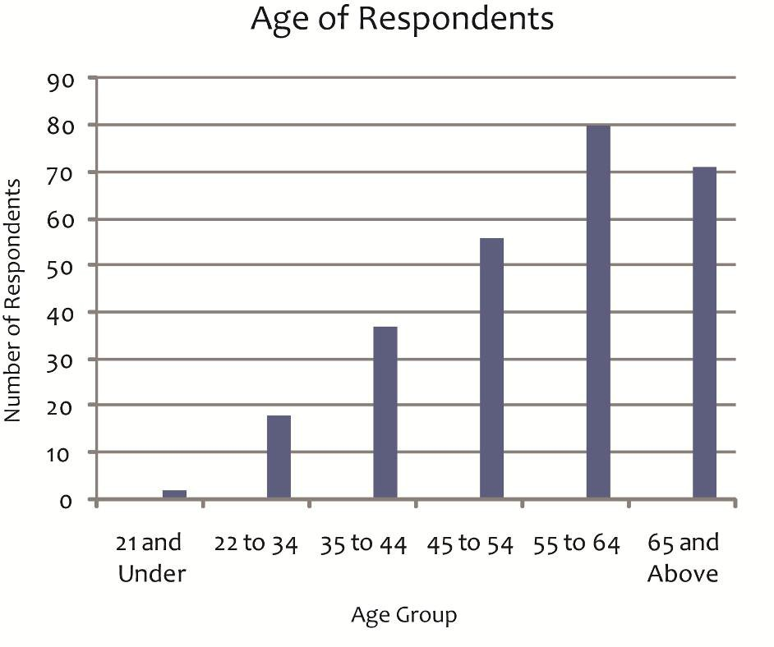

Heritage Consulting Inc

Respondent Demographics
The demographics of the 267 respondents indicated some concentrations of specific groups. Women were the majority of respondents at 68%, and 32% of respondents were men.
Respondents also tended to be older, with a concentration of ages above 55. There was also strong participation from those aged between 35 and 54. The smallest age groups in terms of respondents
were 34 and younger (Figure 3).

Figure 3: Survey results included a concentration of responses from those above the age of 55.

Many respondents also had school‐aged children or grandchildren, 44% of those responding listed school‐aged children or grandchildren, and 56% without children or grandchildren.

8

Where do you find out information about historic and natural sites you plan to visit?
Source | % of  Respondents | # of  Respondents
Internet (Search Engines, Websites, Travel  Host Websites) | 74% | 187
Word of Mouth, Relatives & Friends | 70% | 176
Brochures | 57% | 144
Newspapers | 41% | 102
Newsletters | 36% | 90
E‐Mail Advertisements & Announcements | 32% | 81
Magazines | 30% | 76
Travel Guidebooks (AAA, Frommers, Fodor's, NJ Visitor's Guide) | 28% | 71
Direct Mail | 18% | 45
Social Media (Facebook, Twitter, Blogs) | 16% | 41
Table 1: Respondents turned to the Internet and “word of mouth” when looking for information about historic sites to visit. Direct mail and social media were the least popular sources of information for Whitesbog survey respondents.

How do respondents get information about historic and natural sites?
When respondents plan to visit a historic or natural site they tend to visit the internet first to get information about historic and natural sites they plan to visit. This includes internet search engines, websites, and travel host websites. Seventy‐four percent (74%) of respondents look to the internet when making travel‐planning decisions(Table 1). The second most popular way to find information is through word of mouth. Seventy percent (70%) of the respondents got information from historic sites and natural attractions through word of mouth. Traditional print media such
as brochures, newspapers, newsletters, and magazines are used by 57%, 40%, 36%, and 30% of respondents respectively. The least popular methods of obtaining information about historic sites among respondents were social media (Facebook, twitter, blogs), direct mail, and travel guidebooks, with 16%, 18%, and 28% respectively. A number of respondents added other responses, with only three people listing television‐related media as a source from which they gather information. For this question, respondents were able to select multiple answers, as many responded that they gathered information from multiple sources.

Why do respondents visit historic sites?
When Whitesbog respondents were asked why they visit historic sites they shared a variety of motivations. This survey looked to a Smithsonian study as a basis to classify visitor motivations into experience types.6 The Smithsonian study separated experience types into separate categories including: cognitive experiences, object experiences, introspective experiences, and social

6See “Visitor Experience Types” in Appendix for more information.

experiences. Most respondents to the Whitesbog survey were motivated by the pursuit of information and knowledge as well as enriching their understanding (81% and 73%). This experience type is classified as a “cognitive experience” and the Smithsonian study described visitors who have this motivation as “Individuals whose experience is clearly enhanced by contextual presentations […] describe cognitive experiences as most satisfying. While the objects are still important, these visitors find their primary satisfaction in the interpretive or intellectual aspects of the experience.”7 These visitors are less interested in physical artifacts and more interested in the story, information, and knowledge being shared. Visitors seeking this experience are interested in information, stories, context, and statements of significance of why a place is important and relevant (Table 2).

The next highest category in the Whitesbog study identified respondents who were moved by beauty and enjoyed seeing rare, uncommon, and valuable things (61% and 57%). The Smithsonian study classified these as “object experiences.” These visitors want to see authentic material objects and the “real thing.” They gravitate towards authenticity and materials and historical and natural
objects.8 Visitors seeking this experience like to see, touch, and experience these objects.

Why do you visit historic and natural sites?
Motivation | % of  Respondents | # of  Respondents
Gaining information or knowledge | 81% | 202
Enriching my understanding | 73% | 182
Being moved by beauty | 61% | 152
Seeing rare/uncommon/valuable things | 57% | 143
Imagining other times or places | 50% | 126
Spending time with friends/family/other people | 50% | 125
Feeling a spiritual connection | 24% | 60
Seeing my children learning new things | 24% | 60
Recalling my travels/childhood experiences/other memories | 23% | 58
Feeling a sense of belonging | 22% | 55
Reflecting on the meaning of what I was looking at | 19% | 48
Thinking what it would be like to own special things | 6% | 15
Table 2: Respondents listed the pursuits of information, knowledge, and understanding as top motivations.

Some Whitesbog respondents wanted to imagine other times and places, feel a spiritual connection, and recall personal travels, childhood experiences, and memories (50%, 24%, and
23%). These are classified by the Smithsonian study as “introspective experiences” where visitors

7 Doering, Z., “Strangers, Guests, or Clients? Visitor Experiences in Museums” Paper presented at a conference, Managing the Arts: Performance, Financing, Service, Weimar, Germany, March 17‐19,1999. 11
8 Ibid.

“turn inward, to feelings and experiences that are essentially private, usually triggered by an object or a setting in [a] museum”9 These experiences are highly‐personal and often self‐guided. These introspective experiences emphasize imagination and self‐reflection.

Finally, some Whitesbog respondents also selected “spending time with friends, family, and other people” (50%) as a motivation. Of those respondents with school‐aged children or grandchildren,
46% of those with children selected “seeing my children learning new things” as a motivation.10
Seeing children learn, in addition to spending time with friends, family, and other people are described by the Smithsonian as “social experiences” where visitors value “interaction with someone else as their most satisfying museum experience”11 Visitors seeking this experience enjoy discussion, interaction with friends, and a more leisurely pace.

Each of these motivational categories varied, with visitors selecting different responses. For this question respondents were able to select multiple responses, and results suggest that many respondents have multiple motivations for visiting historic and natural sites.

Each of these experience types: cognitive, object, introspective, and social requires a different program and opportunity for interaction.12 Visitors seeking an introspective or a social experience are less attracted to a guided tour, which is better suited to visitors seeking cognitive and object experiences. Visitors seeking a social experience would likely be more drawn to a festival or hands‐on activity with friends. Special lectures, informational tours, and exhibits would attract visitors seeking a cognitive experience. By varying programming and experience types Whitesbog can accommodate these varying visitor needs.

9 Ibid.
10 From crosstab analysis. Ibid.
11 Ibid.
12 For more information see “Visitor Experience Types” in the appendix of this report.

Please select topic areas of interest to you.
Topic | % of  Respondents | # of  Respondents
Historic Preservation | 75% | 188
Cultural Heritage & Folklife of the Pinelands | 74% | 185
Blueberries | 71% | 179
New Jersey History | 69% | 174
Plants of the Pinelands | 65% | 162
Cranberries | 64% | 161
Ecology | 61% | 154
Open Space & Farmland Preservation | 61% | 152
Agriculture & Agricultural Heritage | 53% | 134
Women's History | 32% | 81
Ethnic Heritage | 32% | 80
Labor History | 22% | 55
Table 3: Historic preservation, cultural heritage, and blueberries were the most popular interests.

Visitors to Whitesbog are interested in a variety of topics, which were closely aligned with Whitesbog’s mission statement. Historic preservation was listed as the top interest, with cultural heritage, blueberry culture, New Jersey history, and plants of the Pinelands close behind. Respondents were able to select multiple answers to this question, and these responses suggest that visitors to Whitesbog had multiple interests. Topics of least interest to visitors included women’s history, ethnic history, and labor history (Table 3).

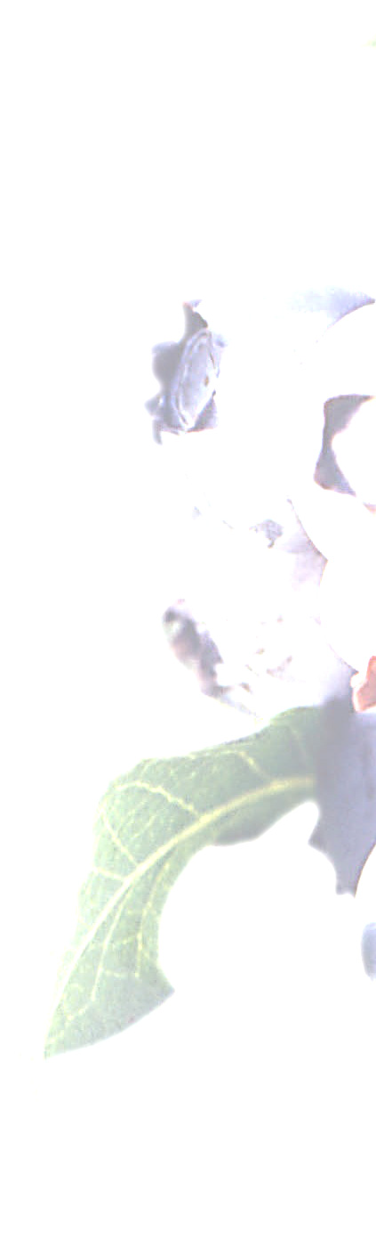

How do you like to learn when you visit a natural or historic site?
Learning Activity | % of  Respondents | # of  Respondents
Guided Walking Tours (Docents, Rangers, Guest Presenters) | 71% | 180
Exhibits (Including Objects, Labels, and Information Panels) | 68% | 173
Printed Brochures for Self‐Guided Tours | 64% | 161
Festivals | 64% | 161
Hands‐on Adult Activities (Demonstrations, Crafts, Plant  Identification) | 54% | 136
Special Lectures on Selected Topics | 53% | 135
Books & Printed Materials | 49% | 125
Interpreters for "First Person" Encounters and Reenactments | 43% | 109
Guided Vehicle/Wagon Ride Tours | 43% | 108
Self‐Guided Electronic Media Tours (Smartphone/iPod) | 25% | 63
Hands‐on Children's Activities (Crafts, Scavenger Hunts, Food) | 22% | 56
Table 4: Respondents listed guided walking tours as the most popular learning activity.

Learning styles
Visitors to Whitesbog liked to learn in a variety of ways. Guided walking tours were the most popular response. These tours are offered by paid or unpaid presenters. Other highly popular learning activities based on survey results including exhibits, printed brochures for self‐guided tours, festivals, and hands‐on adult activities. The least popular activities were hands‐on children’s activities and self‐guided electronic media tours (Table 4). Of those respondents with school‐aged children or grandchildren 37% (40 respondents) selected “hands‐on children’s activities” as a way they like to learn.13 The large concentration of visitors who prefer structured programs and those that prefer unstructured self‐guided experiences is an important distinction. These different visitor groups have different preferences and needs. This is reinforced by the previous section which detailed visitor motivations.

13 From crosstab analysis.

What Whitesbog Preservation Trust programs have you participated in?
Activity/Event | % of  Respondents | # of  Respondents
Annual Blueberry Festival (Last Saturday in June) | 64% | 154
General Store Shopping | 55% | 134
Pinelands Discovery Festival (A Celebration of the Pine Barrens,  First Sunday in October) | 36% | 86
Whitesbog Village Tours | 35% | 84
Suningive House Museum Garden Tours & Nature Walks | 26% | 62
Moonlight Walks | 24% | 58
Volunteer Programs | 22% | 52
Quarterly Lecture Series/Symposiums | 17% | 42
Cranberry Industry Tours (Weekends in October) | 17% | 41
Archives/Oral History Activities | 16% | 39
Tundra Swan Tours (Weekends in December, February, &  March) | 16% | 38
I have not Participated in These Programs | 13% | 31
Whitesbog Winter Celebration | 10% | 24
Table 5: The blueberry festival and general store shopping were the most popular activities among respondents, but a significant minority had not participated in any structured programs.

Participation in Whitesbog Programs
Respondents were active in Whitesbog programs. The most popular program among respondents, not surprisingly, was the Annual Blueberry Festival—followed closely by General Store shopping. Other popular programs included the Pinelands Discovery Festival, Whitesbog Village Tours, and the Suningive House Museum Garden Tour & Nature Walk (Table 5).

Did you participate in any of the self‐guided activities at
Whitesbog?
Activity | % of  Respondents | # of  Respondents
Walking, Hiking, Backpacking | 76% | 123
Solitude & Relaxation | 52% | 84
Photography | 43% | 70
Bird Watching | 39% | 63
Plant Identification | 35% | 57
Dog Walking | 24% | 39
Stargazing | 16% | 26
Running, Biking, Active Exercise | 14% | 23
Boating/Kayaking & Water  Recreation | 10% | 16
Painting/Drawing | 6% | 10
Table 6: Many respondents participated in self‐guided activities at Whitesbog. Walking, hiking, and backpacking were the most popular.

While participation was significant in structured programming at Whitesbog, self‐guided programs were also popular among respondents. Walking, hiking, and backpacking was the most popular self‐guided activity among respondents, as well as solitude and relaxation, photography, bird watching, and plant identification. Water recreation, and painting/drawing were the least popular (Table 6). Respondents were also given an opportunity to enter other activities not included in the list. These responses included cross‐country skiing, and some school‐related teaching activities.

Experience at Whitesbog
Question | Disagree  Strongly | Disagree | Neither  Agree or  Disagree | Agree | Strongly  Agree | Rating
I enjoyed my visit to  Whitesbog | 1.7% (4) | 0.4% (1) | 2.1% (5) | 31.0% (74) | 64.9% (155) | 4.57
I would like to visit Whitesbog  again in the future | 1.3% (3) | 0.0% (0) | 2.1% (5) | 30.0% (71) | 66.7% (158) | 4.61
My experience at Whitesbog  met my expectations | 1.3% (3) | 0.8% (2) | 5.9% (14) | 38.6% (91) | 53.4% (126) | 4.42
Table 7: Visitors highly rated their experience at Whitesbog. (Format: Percent of Respondents, Number of Respondents)

Visiting Whitesbog
Most respondents reported a recent experience at Whitesbog, as more than half (61%) of respondents had visited Whitesbog within the last six months. 19% had visited within the last
year, ten percent (10%) within the last two years, and three percent (3%) more than two years ago. This high proportion of recent experiences suggests that respondents could better recollect their experiences.

In addition, more than half of the respondents were repeat visitors to Whitesbog (58%), visiting more than once within the last year. 41% had not visited more than once within the last year.

Considering how recent their experiences were, visitors to Whitesbog rated their experiences very highly. Of the categories agree and strongly agree, visitors overwhelmingly enjoyed their visit to Whitesbog, would like to visit Whitesbog again in the future, and found their experiences met their expectations. Responses were ranked from 1‐5 on a scale from “Disagree Strongly” to “Strongly Agree.” Rating averages were high, near 4.5 for each question (Table 7).

Evaluation of Impact
Respondents stated that they had enjoyed their visit to Whitesbog, would like to visit again in the future, and that their experience met their expectations, but what did visitors take away from their visit to Whitesbog? What impact did their activities have on them?

Measuring the impact of Whitesbog visits is important because it moves beyond how many people visited Whitesbog and asks “how valuable [were] their visits? What are visitors learning, and how are they inspired to change, think and act differently as a result of their visit?”14

14 Kelly, L. “Evaluation, Research and Communities of Practice: Program Evaluation in Museums” Archival
Science (2004) 45‐69, 48

These impacts are divided into short‐term and medium‐term periods. Short‐term impacts occur immediately after a visit, and are primarily concerned with what visitors learned. Medium‐term impacts occur after a visitor leaves Whitesbog, and are primarily concerned with what visitors did. Whitesbog had a definite impact on the respondents in both the short and medium term. Visitors strongly agreed that they had learned about history, cultural heritage, and the Pinelands environment from their visit. When averaged, they rated consistently above four on a scale from one to five (Table 8 and Table 9).

In the medium term, respondents were motivated to learn more about land conservation and open space preservation, cultural heritage, and historic preservation in their area after their visit to Whitesbog. This is important because it identifies what respondents took away from their visit to Whitesbog, and how it impacted their personal behaviors. Respondents’ average rating for
medium‐term impacts was near 3.75, on a scale from one to five.

Please rate the personal impact(s) you experienced as a result of your visit to Whitesbog.
Question | Disagree  Strongly | Disagree | Neither Agree or Disagree | Agree | Strongly  Agree | Rating
I learned about the history of  Whitesbog | 0.0% (0) | 1.8% (4) | 5.7% (13) | 46.7% (106) | 45.8% (104) | 4.37
I learned about the cultural heritage of the Pinelands | 0.4% (1) | 3.1% (7) | 14.0% (32) | 48.9% (112) | 33.6% (77) | 4.12
I learned about the environment of Whitesbog and the Pinelands(plants, animals, scenic features) | 0.5% (1) | 1.4% (3) | 8.6% (19) | 51.8% (115) | 37.8% (84) | 4.25
My experience at Whitesbog motivated me to learn more about conservation and open space preservation efforts in my area | 0.4% (1) | 3.6% (8) | 36.9% (83) | 35.6% (80) | 23.6% (53) | 3.78
My experience at Whitesbog motivated me to learn more about other areas of cultural heritage. | 0.9% (2) | 4.0% (9) | 37.1% (83) | 35.7% (80) | 22.3% (50) | 3.75
My experience at Whitesbog motivated me to learn more about historic preservation efforts in my area | 0.4% (1) | 3.6% (8) | 37.2% (83) | 35.9% (80) | 22.9% (51) | 3.77
Table 8: Short‐term impacts from Whitesbog were strongest. Medium‐term impacts for Whitesbog were slightly lower than short‐term impacts. Respondents valued their experiences.

Respondents were also asked if they consulted additional resources after their visit to Whitesbog.
42% of respondents answered they did not consult additional resources. When asked if they had become active in organizations as a member, attendee, or contributor after their visit to Whitesbog 64% responded they had not, meaning they had not become involved personally. However, a significant minority, nearly a third of respondents, went on to consult resources in cultural heritage, environment, or historic preservation, showing that these visitors wanted to
learn more about what they saw at Whitesbog. Only a fifth of respondents answered that they had been involved in an organization with respect to cultural heritage, environment, or historic preservation after their visit (Table 9). These results suggest an opportunity for Whitesbog to incorporate a “call to action” to encourage visitors to get involved with ongoing self‐directed learning and organizational involvement as a result of their visit to Whitesbog.

Interpretive materials and programs at Whitesbog can encourage visitors to learn more with internet resources and other media, and suggest a list of these resources. Whitesbog can incorporate a suggestion that visitors get involved in their own community with organizations related to the environment, cultural heritage, and historic preservation as a member, supporter,
or volunteer. Whitesbog can also encourage these visitors to get involved at Whitesbog if they live
nearby.

Did you consult other resources (internet, books, media) on the following subjects to learn more after your visit to Whitesbog? |  |  |  | Did you become involved in any organizations as a member, contributor, or attendee after your visit to Whitesbog in any of the following areas?
Area | % of  Respondents | # of  Respondents |  | Area | % of  Respondents | # of  Respondents
Cultural  Heritage | 31% | 60 |  | Cultural  Heritage | 15% | 30
Environment | 35% | 68 |  | Environment | 18% | 35
Historic  Preservation | 32% | 63 |  | Historic  Preservation | 22% | 44
No | 43% | 84 |  | No | 64% | 126
Table 9: Some respondents consulted additional resources after their visit, and some become active in an organization related to cultural heritage, environment, or historic preservation.

Suggestions for Whitesbog
This survey asked visitors to, “Please share any suggestions to improve your experience at Whitesbog,” and 67 (25%) participants responded. A content analysis of responses illustrates specific requests from respondents. Participants offered targeted suggestions for specific

improvements. Responses are arranged by theme and content area. The following bullet points are unedited comments made by survey respondents.

General Praise
Many respondents offered great praise for the efforts at Whitesbog. Of 67 respondents, 16 (23%)
responded with general praise of activities and programs at Whitesbog.
• Keep up the good work
• Discovering and putting in place more ways to let other people what a fantastic experience
Whitesbog and other areas like it are.
• I think your restoration is great. My family is from Browns Mills, N.J. My grandmother was born in Whitesbog and grew up in one of the workers houses. I'm so proud and excited that my grandmom's birthplace is being restored. Keep up the great work.
• Please keep it the way it is as much as possible ‐ clean, quiet, and with great quality habitat.
• No suggestions, keep up the great work you're doing.
• I visited Whitesbog briefly as part of a Nature Conservancy bird walk in 2008. That day got me hooked on birding!

Interpretive Activities
Respondents had many suggestions for improved interpretation at Whitesbog. These ranged from general way finding signage to improved brochures and printed materials as well as additional volunteers to provide interpretation. Suggestions included expanding interpretive resources available for visitors (maps, brochures, etc.) when facilities are not open. There were five requests for a map with trails and facilities that was easily available both during open hours and after hours when buildings were closed.
• Improved signage. Very easy to miss turns.
• There are numbered signs along the driving tour but no explanations other than in the brochure. Would also be nice to have signage identifying things of interest (plants and flowers, birds, frogs, etc) that inhabit the preserve.
• More access to printed pamphlets telling the story of the village and the farmlands.
• Wouldn't it be wonderful to have on site interpretive staff. We can only hope!
• A map board (such as those marking trails at places like the Edwin B. Forsythe reserve in Brick NJ, or Allaire village) w. map/brochures would be helpful AND would alleviate the need for a guide. If the board also included a biography/history of each house (such as the one @ Carranza Memorial). Anyone could stop by at any time and leave knowing something new without needing a tour guide.
• The only thing I would add would be a sign for walkers/joggers giving an estimate of the distance for the trails. 1/4 mile, 1/2 mile, etc.
• I guess it would be nicer to have more tour guides or knowledgeable people at Whitesbog.
The last time I was there, there were only a few people informing the public, so staffing

the area better would be my only suggestion. There are so many kids graduating with degrees in agriculture and ecology, let's give some young people jobs.

Advertising and Publicity
Respondents expressed a need for better publicity for Whitesbog events and activities. Some respondents were unaware of the breadth and scope of activities available at Whitesbog.
• Publicize events more and a little longer in advance; reach out to the homeschooling community.
• Difficult to find out what is going on at Whitesbog.
• I was participating in a festival which was not well attended at all. It is a great location and a beautiful place I suppose you just have to keep on trying to inform the public that it is there. You can build a better mouse trap, but if no one knows about it, it really does not matter how good it is. So you have to be in people's face about it all the time, getting all
the grants you can, offering it as a community establishment, where organizations can meet, keep doing special events. Word of mouth takes a long time, but it is effective, so the more people you can connect to the place, the more they will tell their friends and family and the word will get out.
• Better publicity for upcoming festivals.
• Love coming but would like events advertised sooner so I can get off work.

Requests for Specific Programs and Activities
Respondents shared some of their ideas for new programs and activities at Whitesbog. Some suggestions were very specific, while others were broader. The most popular topics related to school programming, but there was no unanimity in responses.
• Add more exhibits of early 20th Century artifacts, equipment and lifestyles.
• Offer community education type classes for adults in art, photography, wood carving, etc.
Also consider having guided bicycle tours. Riding bikes at WB is a lot of fun.
• Please offer more affordable classes for grade school children so Pemberton Township can attend Lenape and Company Town field trips.
• I would like to see the Whitesbog Halloween party back again like it was long ago.
• Offer discounted services for school field trips for township residents!
• Education on raising blueberries.
• I wish you bring back hayride, story tell marshmallow roast at Halloween time, it probably ended 18 yrs ago it was great for the family.
• More booths of every kind, esp. local foods. How about a produce stand? Really like the ice cream sundaes.
• Have a bakery on premises.
• Whitesbog is great and I tell folks all the time. I rarely participate in organized activities, because I prefer to do and experience things on my own terms.

General Store and Facilities Suggestions
The general store was a point of interest for six respondents. Some responses suggested longer operating hours during peak times, varied merchandise mix, and some visitor amenity needs.
• Open store on Fridays ‐ especially during the summer months.
• Should open on Fridays
• I believe Whitesbog has enough historic and cultural significance for New Jersey to warrant a new visitor's center with room for conferences, meetings, lectures, and exhibits. I believe that the entrance access road and bridge should be improved for safety and better traffic flow.
• A better variety in general store
• Could sell more blueberry and cranberry items at the store and online. Could probably sell more refreshments/food there. I realize it is not meant to be a commercial enterprise, but people need NJ souvenirs (tasteful ones) and people get hungry/thirsty out walking.
• Restroom accessibility, even at times when the store is closed.
• Porta potties.

Blueberry Festival Feedback
A number of participants offered specific feedback for the blueberry festival, a very popular event. Due to the problems this year with capacity, some visitors were turned away by police, and respondent comments expressed disappointment with the closure due to full capacity.
• The Blueberry Festival gets better every year!! Thanks for the memories!
• Love Whitesbog. However on our last visit during the Blueberry Festival we took a hay ride and were bitten very badly by bugs that were in the hay. Would highly recommend that you use a plain wagon with benches in the future. Loved the ride into the bogs.
• I've been a paying member for more than ten years, you should have heard me scream when I was prevented from entering this year’s blueberry festival because the grounds were full. I would think that members would be permitted entry regardless. Not a happy member.
• It was very difficult to get into the blueberry festival. The police officers were rude and there was no explanation when turning away the visitors. They wouldn't even allow people to walk into the festival if they didn't have a car. Please research additional parking lots that could be used in the future for additional visitors to the festival.

Impact Responses
In terms of outcomes, participants were asked if their visit to Whitesbog affected them in any other way not mentioned. Participants shared a variety of outcomes from their experiences with Whitesbog. Below are a collection of responses. Fifty eight people responded to this question.
• Became a master gardener in Burlington county
• Renewing my commitment to help preserve NJ's Pinelands.
• Just to be involved and inspired to teach others about our natural world.
• Started my interest in the Pine Barrens

• Read books about Pinelands.
• I better appreciate locally grown fruit. I realize that machine (vs. hand picking) will most likely effect the quality of fruit in the future, making it more durable, but probably less tasty. I may get involved in more "pick your own" activities.
• Peace of mind, beauty in every season, wonderful place for my Dobermans to enjoy!
• My visit inspired me to want to get out and visit more historic sites. Whitesbog and Batsto are at the top of my list and I’ll be attending tours soon.
• Whitesbog enriched my understanding of the area's history and cultural development. Recommendations
Whitesbog is important to its visitors and audiences. These survey results offer a variety of suggestions to Whitesbog. These included more general as well as highly specific recommendations.

• Improve website and web resources for current and potential visitors. The internet is the first place most respondents look in order to plan their visit to historic and natural sites. An attractive website, social media presence, and links to other resources is an excellent opportunity to reach these current and potential visitors. Use the Whitesbog website for promotion and advertising Whitesbog’s events. Keep the web site current an update at least weekly.
• Improve publicity efforts. Publish Whitesbog events early, and publicize them in many venues using traditional as well as social media. There is still a place for calendar listings in the local and regional newspaper. When asked for suggestions to improve Whitesbog respondents cited a lack of knowledge as a reason they could not attend programs.15 More people will know about an event if it is promoted for a longer period of time.
• Accommodate both structured and unstructured uses of Whitesbog. Respondents expressed support for structured programs like guided tours, exhibits, and festivals.16 But many also expressed desire for self‐guided brochures and individual experiences.17 This reveals that a “one‐size fits all” approach is insufficient for visitor needs. Providing a mix of opportunities can accommodate a variety of user groups. Better resources for self‐guided experiences are crucial for the “hidden users” who visit Whitesbog after hours, or explore parts of the site which are not formally interpreted. Specific recommendations from users for better signage, printed materials, and web resources are a beginning.
• Vary programming opportunities. Whitesbog visitors were motivated by cognitive, object, introspective, and social experiences.18 Self‐guided experiences, “hands‐on” activities, special lectures, and festivals accommodate a variety of visitor motivations.

15 See thematic section “Advertising and Publicity” p 18
16 See Table 4
17 See thematic section “Interpretive Activities” p 19
18 See Table 2

Whitesbog should continue to provide diverse programming to accommodate these varying visitor motivations.
• Consider new self‐guided programming. Strong interest in walking and hiking, photography, bird watching, and plant identification presents an opportunity for new self‐ guided opportunities. Consider publishing brochures such as A Photographer’s Guide to Whitesbog, Birds of Whitesbog, Plants of Whitesbog, offering tips for these specific audiences. If these brochures are published make sure these are uploaded as
downloadable PDF documents as additional resources on Whitesbog’s website. Allow self‐ guided users to share their experiences online through photography and animal and plant sighting logs, adding a level of interactivity. Consider incorporating these through flickr and Facebook pages.
• Consider specific recommendations from users. Suggestions such as general store hours, signage for joggers, wine tastings, marshmallow roasts, and improved advertising offer discrete opportunities to improve Whitesbog with specific recommendations from people who have visited or enjoy Whitesbog on a regular basis.
• Consider popular themes. Visitors were most interested in historic preservation, cultural heritage and folklife of the Pinelands, blueberries, New Jersey history, and the natural environment of the Pinelands. Review current programming and emphasize these topics in the coming year.
• Celebrate success. Visitors gave Whitesbog high marks in terms of satisfaction, and personal impacts closely matched Whitesbog’s mission statement. These high marks are a testament to the hard work of the volunteers, staff, and supporters of Whitesbog.
• Continue a program of ongoing evaluation. This survey and study provides a framework for continued evaluation with a specific emphasis on short and medium‐term impacts for visitors. Provide a link to the web survey on Whitesbog’s website, send out this survey as an annual survey to track changes and trends over time. Attached in the
appendix is a sample program evaluation form.
• Incorporate a “call to action” to personalize the visitor experience. Whitesbog visitors clearly valued their visits. In order to offer deeper personal impact and opportunities for visitors after they leave Whitesbog programming should encourage visitors to get involved at Whitesbog as a member or volunteer. For those who live farther away, encourage participants to get involved in historic preservation, cultural heritage, and the environment in their local area as a member, contributor, and volunteer.

Credits
Alexander Balloon is a consultant for Heritage Consulting Inc. Mr. Balloon has experience in both historic preservation planning and research design. He began work with the firm in 2008. With Heritage Consulting, Mr. Balloon has completed several major projects including historic preservation planning, Main Street program evaluation, architectural research, heritage tourism product development, public involvement, and impact evaluation. He has assisted in public engagement activities, research and analysis, and provided graphic design and production. In 2011

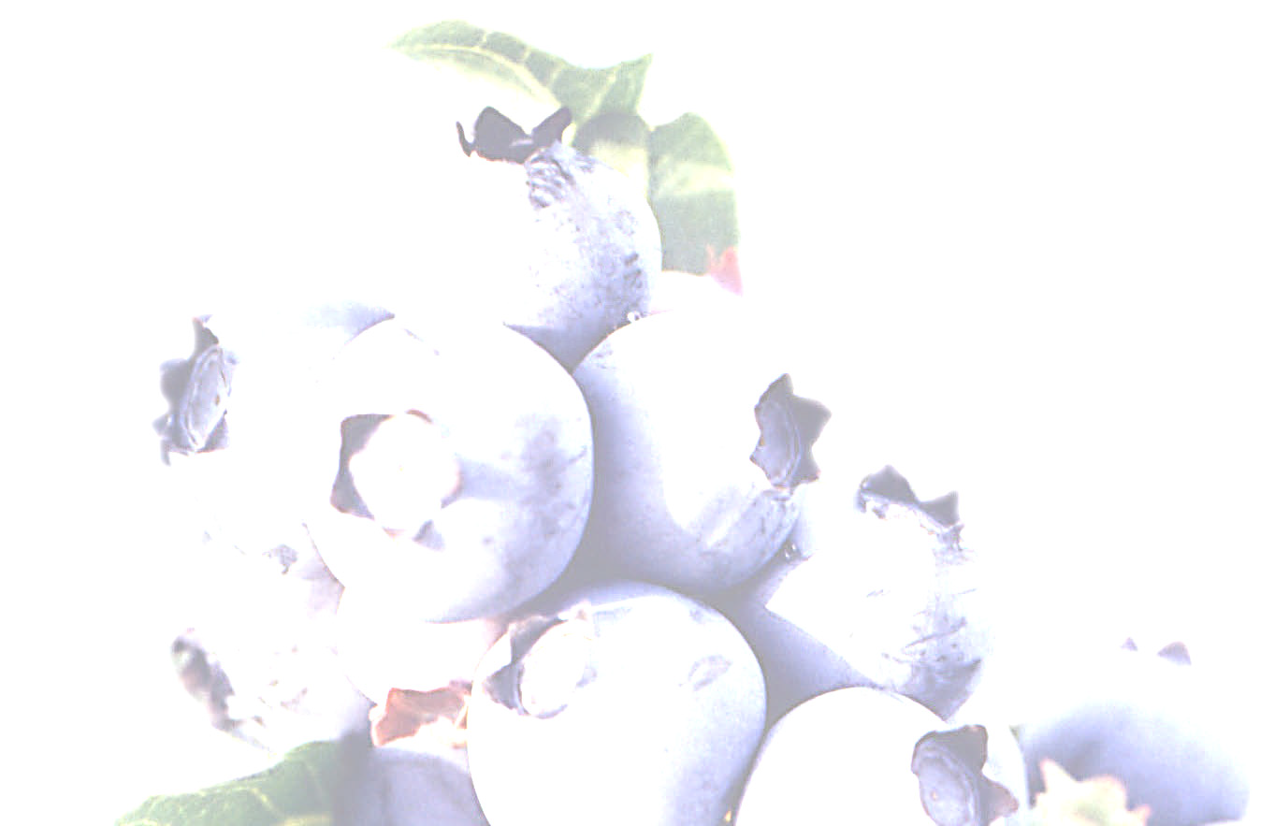

24

he shared the Grand Jury Prize from the Preservation Alliance of Greater Philadelphia for his work for the Delaware County Public History Feasibility Study and Implementation Plan.

Prior to his work with Heritage Consulting Inc., Mr. Balloon drafted a preservation plan for the University City area of the City of Philadelphia for the University City Historical Society. He has completed a variety of projects in the City of Philadelphia and elsewhere including documentation, feasibility, and re‐use studies for historic sites and properties. He also has experience in evaluation and research design, working with non‐profit clients. Mr. Balloon has a Master of Science degree from the University of Pennsylvania’s Graduate School of Design in Historic Preservation and a Graduate Certificate in Urban Redevelopment. Mr. Balloon earned a Bachelor of Arts degree in Urban Studies and History from the College of Wooster in Ohio.

Donna Ann Harris is the principal of Heritage Consulting Inc., a Philadelphia‐based consulting firm that works in three practice areas: downtown and commercial district revitalization, historic preservation and organizational development. Since starting her firm and during her career

Donna has assisted citizen groups and government agencies to identify appropriate reuses for threatened historic properties that ensure the long term preservation and maintenance of the site. Throughout her twenty five years in the preservation movement, she has led start‐up and mature statewide preservation organizations as an executive, was first staff member of a land and
building conservation organization, and was project manager for a citywide preservation organization. Donna was the founding Executive Director for Preservation New Jersey from 1980‐
1982. Donna’s new book New Solutions for House Museums: Ensuring the Long‐Term Preservation of America’s Historic Homes was published by AltaMira Press in April 2007. She has published articles about reuse of historic house museums in the American Association for State and Local History’s quarterly magazine History News and the National Trust for Historic Preservation’s quarterly scholarly journal Forum Journal. Her articles about advocacy, membership development and Business Improvement Districts have been published in the National Trust Main Street Center’s monthly newsletter Main Street News. Donna speaks regularly and consults about historic preservation issues around the country

Graphics: All graphics by Alexander Balloon. Cover photographs by Alexander Balloon.

Appendix:

Visitor Experience Types Program Evaluation Form Survey

Visitor Experience Types19

This appendix details the different types of experiences for visitors to Whitesbog, and details the different types of experiences that motivate visitors.

Social experiences
Spending time with friends / family/ other people
Seeing my children learning new things
Object experiences
Being moved by beauty
Seeing rare/uncommon/valuable things
Cognitive experiences Enriching my understanding Gaining information or knowledge
Reflecting on the meaning of what I was looking at
Introspective experiences Feeling a spiritual connection Imagining other times or places
Thinking what it would be like to own such things
Recalling my travels/childhood experiences/ other memories
Feeling a sense of belonging

Social Experiences: Some visitors select an interaction with someone else as their most satisfying museum experience. These visitors would be attracted to social programming and events that include but are not limited to: festivals, wine tastings, marshmallow roasts, wagon rides, blueberry picking, family programs, storytelling, and children’s crafts (pre‐school and elementary school).

Object Experiences: In the social experiences visitors describe as most satisfying, the focus is on one or more other people. Object experiences focus on physical artifacts and the “real thing.” These visitors are drawn to authenticity and direct sensory experiences to see, touch, taste, smell, and hear a place. These visitors are drawn to behind the scenes tours, bird watching, plant identification, blueberry tasting, bake‐offs, watching cranberry harvesting, agricultural implements, and hands‐on crafts.

Cognitive Experiences: Individuals whose experience is clearly enhanced by contextual presentations tend to describe cognitive experiences as most satisfying. While the objects are still
important, these visitors find their primary satisfaction in the interpretive or intellectual aspects

19 This is adapted from Doering, Z., “Strangers, Guests, or Clients? Visitor Experiences in Museums” Paper presented at a conference, Managing the Arts: Performance, Financing, Service, Weimar, Germany, March 17‐
19,1999. 11

of the experience. Programs that emphasize cognitive experiences include: guided tours, special lectures, exhibits, school educational programming (elementary and above), hands‐on environmental technical programs (stream monitoring, bird counting, plant identification, and astronomy), hands‐on historical technical programs (archiving and oral histories), and learning how to grow blueberries.

Introspective experiences: These experiences are when the individual turns inward, to feelings and experiences that are essentially private, usually triggered by an object or a setting at the site. These visitors enjoy self‐guided walking tours and exhibits as well as solitude and relaxation. Introspective experiences are highly personal and require opportunities for self‐reflection.

Sample Event: Blueberry Festival
An event like the Whitesbog Blueberry Festival is an excellent example of a program that offers many of these types of experiences. With so many mini‐programs and elements, visitors seeking a cognitive experience can collect historical literature, attend a lecture, take a walking tour, and
visit the agricultural museum, cranberry substation, and general store. For those seeking a social experience there is a pie‐eating contest, live music, food, children’s activities, and crafts.

For visitors who want object experiences, there are crafters and artisans, historical machines and equipment, tours through historic buildings and natural areas, as well as shopping. Finally, for those seeking an introspective experience there are walking trails including natural scenery, self‐ guided exhibits, and blueberry picking. As a large‐scale event, the blueberry festival incorporates different experiences to accommodate visitor needs.

Program Evaluation Form

Included is a sample program evaluation form. This form was developed from Whitesbog’s existing program evaluation form and serves as a template for future program evaluation
activities. The form includes a selection of questions including: where attendees learned about the program, what attendees learned, and what attendees planned to do after they left the event. Also included in the form are spaces for suggestions and program feedback. This form should be used
as a model and adapted to specific program and event needs in the future. Program attendees should be surveyed after events and programs regularly.

Program Evaluation Form
Please take a moment to complete our program evaluation. This evaluation form is part of an ongoing effort to improve our visitor services, develop new programs, and measure our program’s effectiveness. Thank you for helping us.

1. How did you hear about this program? (Please check all that apply)

Program flyer
Annual listing of events
Whitesbog email
Whitesbog website
Media announcement
Email from other organization
From friends or associates
Other (Please Specify)

2. Please share your experience with us:

Question | Disagree  Strongly | Disagree | Neither Agree or Disagree | Agree | Strongly  Agree
I learned about the history of
Whitesbog
I learned about the cultural
heritage of the Pinelands
I learned about the environment
of Whitesbog and the Pinelands
(plants, animals, scenic features)
My experience today motivated
me to learn more about conservation and open space preservation efforts in my area
My experience today motivated
me to learn more about other areas of cultural heritage.
My experience today motivated
me to learn more about historic preservation efforts in my area

3. Do you have any suggestions to improve today’s program?

4. Do you have topics or ideas for future programs?

5. Are you a member of the Whitesbog Preservation Trust? YES/NO

6. Do you visit the Whitesbog Preservation Trust’s website www.whitesbog.org regularly? YES/NO

7. If you answered no, and would like information about membership or volunteering please provide your contact information, and we will contact you soon.

Name:

Email: Telephone:

Street Address:

City, State, Zip:

Thank you for completing this evaluation. Your valuable comments help us assess and improve our programming and visitor services.

1. Introduction

Dear Prospective Participant:

You are being invited to participate in an anonymous survey for the Whitesbog Preservation Trust. You were selected as either a recent visitor or potential visitor to Whitesbog. Your participation in this survey helps Whitesbog better match programming to the needs and interests of current and future visitors. This survey is expected to take 10­15 minutes to complete. Your participation is completely voluntary, and your responses will be
kept confidential.

1. What is your gender?

fec
Female
fec
Male

2. In what range is your age?

mlj
21 and Under

mlj
22 to 34

mlj
35 to 44

mlj
45 to 54

mlj
55 to 64

mlj
65 and Above

3. Do you have school­age children or grandchildren?

mlj
Yes

mlj No

2. Leisure Habits & Learning Styles

4. Where do you find out information about historic and natural sites you plan to visit?
(Check all that apply)

fec
Brochures
fec
Newsletters

fec
Direct Mail
fec
Newspapers

fec
E­Mail Advertisements & Announcements
fec
Social Media (Facebook, Twitter, Blogs)

fec
Internet (Search Engines, Websites, Travel Host Websites)
fec
Travel Guidebooks (AAA, Frommers, Fodor's, NJ Visitor's Guide)

fec
Magazines
fec
Word of Mouth, Relatives & Friends

Other (please specify)

5. Why do you visit historic and natural sites? (Check all that apply)

fec
Being moved by beauty
fec
Recalling my travels/childhood experiences/other memories

fec
Enriching my understanding
fec
Reflecting on the meaning of what I was looking at

fec
Feeling a sense of belonging
fec
Seeing my children learning new things

fec
Feeling a spiritual connection
fec
Seeing rare/uncommon/valuable things

fec
Gaining information or knowledge
fec
Spending time with friends/family/other people

fec
Imagining other times or places
fec
Thinking what it would be like to own special things

6. Please select topic areas of interest to you. (Check all that apply)

fec
Agriculture & Agricultural Heritage
fec
Historic Preservation

fec
Blueberries
fec
Labor History

fec
Cranberries
fec
New Jersey History

fec
Cultural Heritage & Folklife of the Pinelands
fec
Open Space & Farmland Preservation

fec
Ecology
fec
Plants of the Pinelands

fec
Ethnic Heritage
fec
Women's History

7. How do you like to learn when you visit a natural or historic site? (Check all that apply)

fec
Hands­on Adult Activities (Demonstrations, Crafts, Plant
fec
Exhibits (Including Objects, Labels, and Information Panels)

Identification)

fec

Guided Vehicle/Wagon Ride Tours

fec fec fec
fec
Hands­on Children's Activities (Crafts, Scavenger Hunts, Food) Books & Printed Materials
Guided Walking Tours (Docents, Rangers, Guest Presenters)

Interpreters for "First Person" Encounters and Reenactments

fec fec fec

Self­Guided Electronic Media Tours (Smartphone/iPod) Special Lectures on Selected Topics
Festivals

fec
Printed Brochures for Self­Guided Tours

3. Your Experience at Whitesbog

*8. How recently have you visited Whitesbog? (Select One)

mlj

Within the Last Six Months

mlj
Within the Last Year

mlj
Within the Last Two Years

mlj
More than Two Years Ago

mlj
I have not Visited Whitesbog

4.

9. Why have you not visited Whitesbog? (Check All That Apply)

fec
Too Far Away
fec
No Children/Occasion to go for

fec
No Particular Reason
fec
No Time/Too Busy

fec
Not Familiar With Whitesbog
fec
Health Concerns/Limitations

fec
Dislike the Outdoors
fec
Dislike Historic Sites

fec
Prefer Other Activities/Destinations
fec
Too Expensive

5.

10. Have you visited Whitesbog more than once within the last year?

mlj
Yes

mlj No

11. What Whitesbog Preservation Trust programs have you participated in? (Check all that
apply)

fec
Cranberry Industry Tours (Weekends in October)

fec
Pinelands Discovery Festival (A Celebration of the Pine Barrens, First Sunday in October)

fec
General Store Shopping

fec
Archives/Oral History Activities

fec
Moonlight Walks

fec
Tundra Swan Tours (Weekends in December, February, & March)

fec
Whitesbog Village Tours

fec
Whitesbog Winter Celebration

fec
Quarterly Lecture Series/Symposiums

fec
Annual Blueberry Festival (Last Saturday in June)

fec
Suningive House Museum Garden Tours & Nature Walks

fec
Volunteer Programs

fec
I have not Participated in These Programs

12. Did you participate in any of the self­guided activities at Whitesbog?

fec
Boating/Kayaking & Water Recreation

fec
Dog Walking

fec
Running, Biking, Active Exercise

fec
Solitude & Relaxation

fec
Walking, Hiking, Backpacking

fec
Bird Watching

fec
Painting/Drawing

fec
Photography

fec
Plant Identification

fec
Stargazing

Other (please specify)

6. Your Experience at Whitesbog

13. Please rate your experience(s) at Whitesbog

Disagree Strongly Disagree

Neither Agree nor
Disagree

Agree Strongly Agree

I enjoyed my visit to
Whitesbog

I would like to visit Whitesbog again in the future
My experience at Whitesbog met my expectations

nmlkj nmlkj nmlkj nmlkj nmlkj mlj mlj mlj mlj mlj

nmlkj nmlkj nmlkj nmlkj nmlkj

14. Please share any suggestions to improve your experience at Whitesbog

5

6

7. Impact Evaluation

15. Please rate the personal impact(s) you experienced as a result of your visit to
Whitesbog.

Disagree Strongly Disagree

Neither Agree or
Disagree

Agree Strongly Agree

I learned about the history of Whitesbog
I learned about the cultural heritage of the Pinelands
I learned about the environment of Whitesbog and the Pinelands(plants, animals, scenic features)
My experience at Whitesbog motivated me to learn more about conservation and open space preservation efforts in my area
My experience at Whitesbog motivated me to learn more about other areas of cultural heritage.
My experience at Whitesbog motivated me to learn more about historic preservation efforts in my area

nmlkj nmlkj nmlkj nmlkj nmlkj mlj mlj mlj mlj mlj nmlkj nmlkj nmlkj nmlkj nmlkj

mlj mlj mlj mlj mlj

nmlkj nmlkj nmlkj nmlkj nmlkj

mlj mlj mlj mlj mlj

16. Did you consult other resources (internet, books, media) on the following subjects to
learn more after your visit to Whitesbog? (check all that apply)

fec
Cultural Heritage

fec
Environment

fec
Historic Preservation

fec No

17. Did you become involved in any organizations as a member, contributor, or attendee
after your visit to Whitesbog in any of the following areas? (check all that apply)

fec
Cultural Heritage

fec
Environment

fec
Historic Preservation

fec No

18.Did your visit to Whitesbog influence you in another way not previously mentioned?

I

19.Thank you for your participation.Please enter your e-mail address if you would like to receive periodic updates and invitations to special programs.We do not share or sell our email lists.

